RAUDRANEX AEROSPACE WEBSITE DRAFT

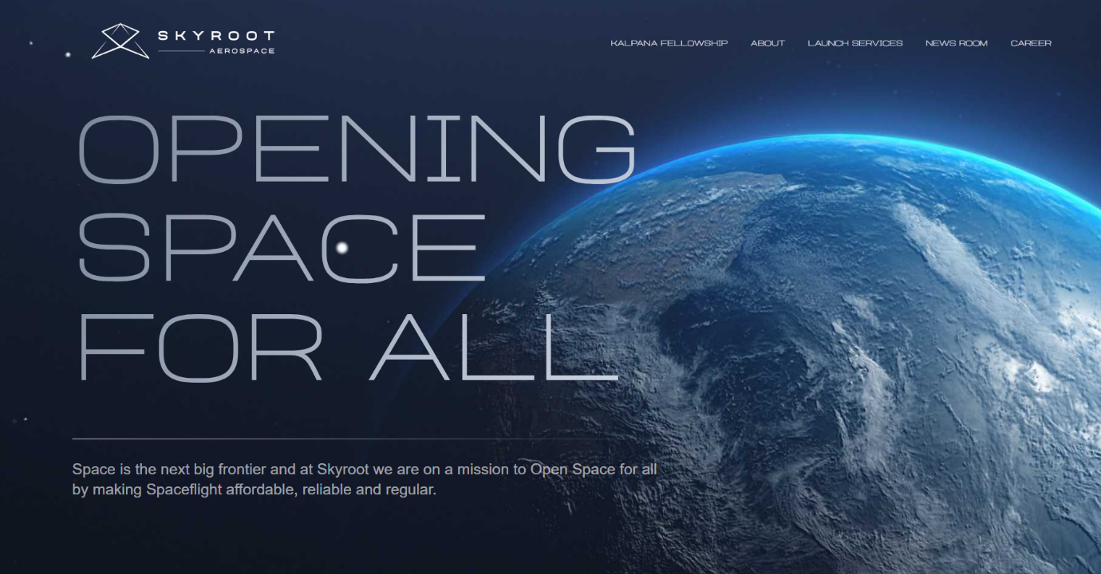
Font style as same as sky root aerospace website
opening page to be as similar to this website
website- www.skyroot.in
Page length exactly similar to Dream aerospace
website- https://www.dreamaerospace.in/
Roughly the length and the skeletal sketch of the website


This particular address box to be added on each page of the website
Pages to be represented
presently the first page as discussed above called
HOME page.
the following are the headings of each page
HOME PRODUCT ABOUT UPDATES CAREER CONTACT
Reference from sky root website for the main menu box
1.HOME
As already described above
2.PRODUCT
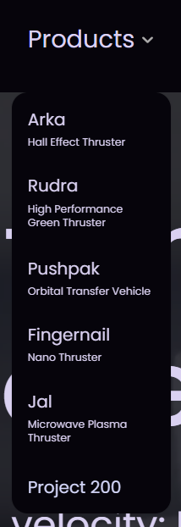
Reference from Bellatrix aerospace website
Website- https://bellatrix.aero/
And a detailed page to be opened for each product
3.ABOUT
A brief note about Raudranex aerospace pvt ltd
Team Representation
Advisory board
Partners
4.UPDATES
Reference from Dhruva aerospace newsroom page
5.CAREER

Reference from Agnikul website
website- https://agnikul.in/#/career

6.CONTACT
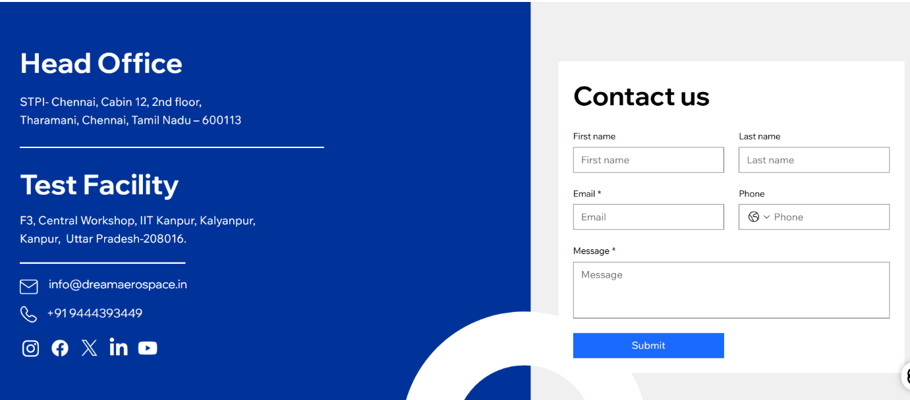
Reference from Dhruva aerospace
All the company logos and necessary information will be provided

